# API INTEGRATION REPORT

## **DAY 3:**

## API INTEGRATION PROCESS

In day 3, I learned how to integrate API’s in Next.js project and also hands-on experience with API migration.in this we update product schema to include new fields like tags, Images, Code, Discount percentage. In this we also use migration scripts to transfer data and ensuring that the data matches the schema.

## ADJUSTMENTS MADE TO SCHEMAS

For product schema I used several new fields like

* Code
* Inventory
* Tags
* Discount percentage
* Images

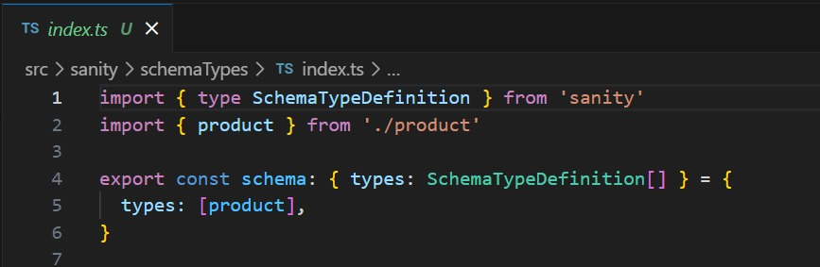

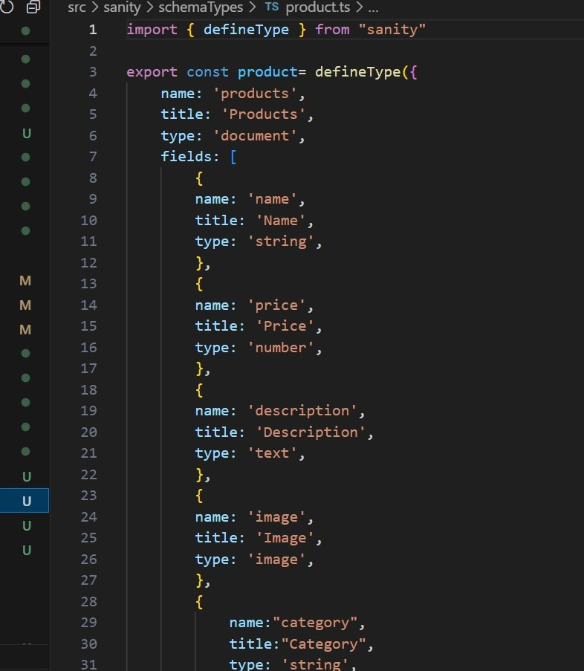

## MIGRATION STEPS

* Backup data
* Deploy updated schema
* Update schema
* Inspect data
* Test locally
* Validate data
* Deploy to production

## **MIGRATION TOOLS USED**

* Sanity CLI
* Sanity Studio
* Sanity Dashboard
* 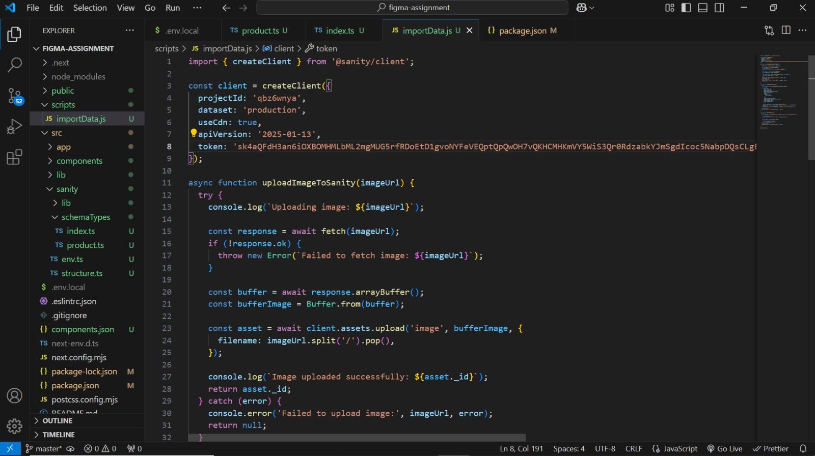GROQ Queries

## FRONTEND DISPLAY

A function was implemented to fetch migrated data from sanity CMS.

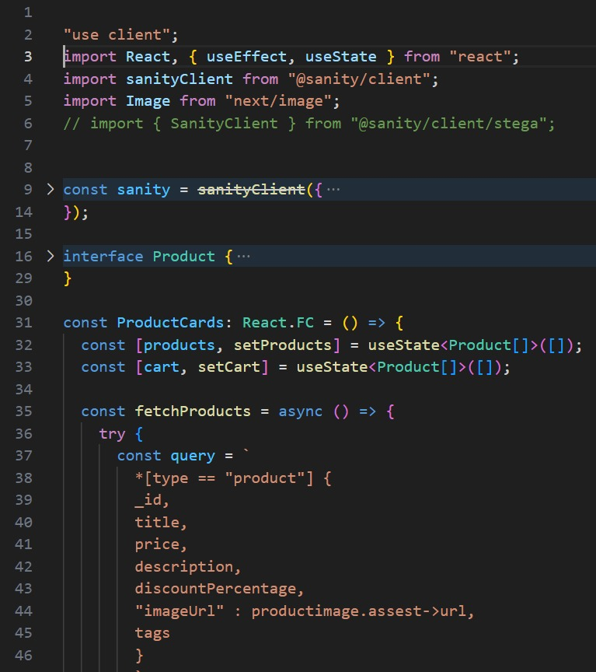

## **C:\Users\Com Plus\Desktop\5.jpg**API CALL OUTPUT

## SANITY CMS DATA ENTRY

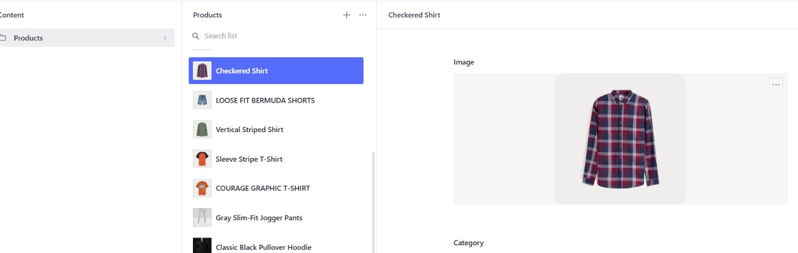Product entry with all fields filled out.

## DATA VALIDATION

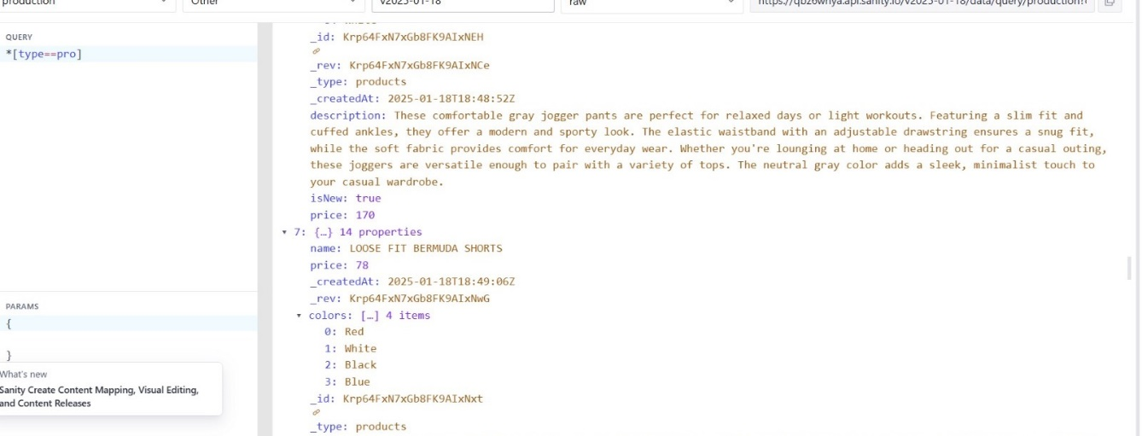GROQ query showing correct data.

## SELF-VALIDATION CHECKLIST

|  |  |
| --- | --- |
| * API understanding |  |
| * Schema validation |  |
| * Data migration |  |
| * API Integration in Next.js |  |
| * Submission preparation |  |

## CONCLUSION

In hackathon day 3, the API integration process for the E-commerce platform was successfully implemented using Next.js, Axios and Sanity CMS.By validation and adjusting the schema, I learned how to align it with the API structure, ensuring compatibility and smooth data migration.

The overall process improved my skills in error handling, creating utility function and testing data integration to maintain a high-quality user experience. This project was a great opportunity to enhance my understanding of working with API’s data migration and frontend integration using Next.js.